INTRODUCTION

This is a course capstone project intended to demonstrate the application of the knowledge you have gained about the analysis and design of object-oriented software. To that end, you are going to base your work on the Professional and Scientific Staff Management (PSSM) minicase (#2) begun at the back of chapter 4 on pp.161-162. The case continues in chapter 6 (minicase #1) on pp.237-238. To get you started, a use-case diagram is given to you:

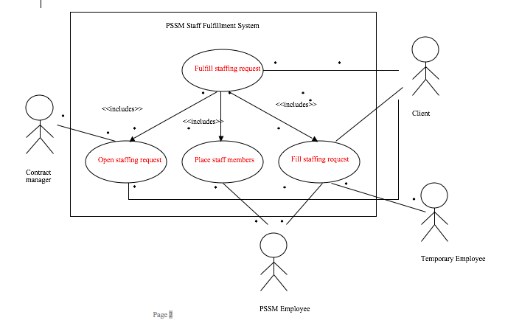

PROJECT DESCRIPTION

You will produce a hybrid workproduct for this project. In a single document, you will combine pieces of project management, analysis, design, and test documentation. This will be one single .docx or .pdf format document.

The document you produce should be a well-written, business document. I expect it to be of a level of quality and clarity of something you would present to a customer of your business. This essentially means, you stake your reputation on the quality of the document, both presentation and content. It should be well-written, clear and concise, well-organized, and complete (per the content requirements of this assignment). It should be written to your target audience: your customer. You cannot expect your customer (PSSM) to have any technical knowledge so you need to explain things in a way that they will understand what each section of the document is attempting to present.

Your document should read like a presentation of this project. It should have a table of contents, an introduction that presents the problem statement and the purpose of the project, a body that presents the workproducts described below, and a conclusion that summarizes the document and “concludes” the presentation.

Your work will be evaluated on four criteria:

* document quality - 50 points
* proper audience – 25 points
* completeness – per the content requirements – 50 points (harsh deductions for missing item(s))
* correctness – syntax, format, logic – 75 points

DUE on paper and electronically via Blackboard at the beginning of class on December 7. Group assignment – only one member needs to submit it electronically.

PROJECT CONTENTS:

NOTE: each of the following should be presented in sections in your document (you can dictate the scope of a given section and the sequence of sections) and each section should explain the contents to the audience in terms of what is being presented and why it is important.

* you should describe the system to be created
  + Textual description – maybe a, or several, narratives of how the process works
  + Use case diagram – given
  + Activity diagram(s) for the overall business process(es) – can probably do this in one diagram, given the nature of the use case diagram
* Describe the effort it will take to create such a system (note: purchasing an existing software package IS NOT an option for this project)
  + Perform a use case points analysis and present the results (note: you might want to define the use-cases first!)
* Present the detailed analysis of the problem
  + Described in the two minicases listed above in the book.
* Detailed design – for this section, you will create a write-up explaining how you would design the data management layer for this system – you can include the necessary updates to the class diagram depicting the DM layer if you choose, but it is not required.
* Human-Computer Interface Design
  + Use scenarios for all use cases (from the book “The key point with using use cases for interface design is *not* to document all possible use scenarios with a use case. The goal is to document two or three of the most common use scenarios [for each use case] so that the interface can be designed to enable the most common uses to be performed simply and easily.” P.374)
  + Windows Navigation Diagram(s) (WND) covering the entire system’s functionality. P.375
  + Storyboard(s) covering the entire system’s functionality.
* Physical Architecture Design
  + A system deployment diagram (appropriately complex)
  + Descriptions of the non-functional requirements relating to the physical architecture layer design
    - Operational
    - Performance
    - Security
    - Cultural and Political
* System Test Plan
  + A system level user acceptance test plan describing the test to be run to verify that this system meets its functional requirements (and basic security requirements). (Template TBD)
    - The challenge here will be to write a test plan without a requirements document. Note that many development organizations develop software by starting with detailed test descriptions (one simple view of this practice is that it kills two birds with one stone – a test plan and a requirements document all in one!)
* A conversion and change management plan for deploying the system at PSSM – you will have to make some assumptions here.